1. SELECT * FROM `pelanggan` ORDER BY nama ASC;

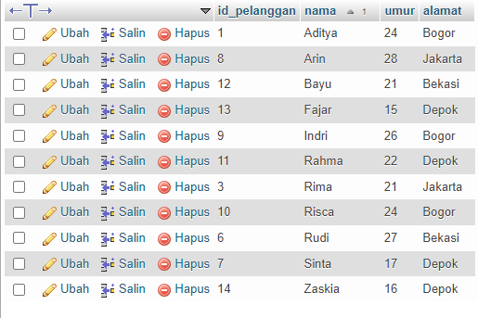

1. SELECT * FROM `pelanggan` ORDER BY nama DESC;

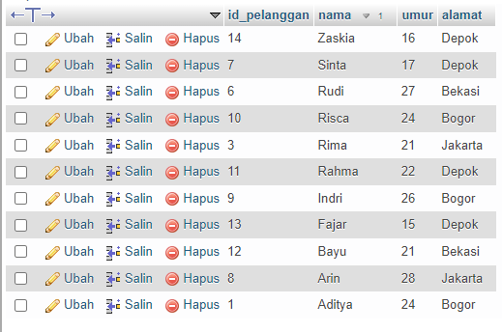

1. SELECT * FROM `pelanggan` WHERE alamat LIKE ‘%Bogor%’;

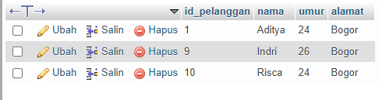

1. SELECT * FROM `pelanggan` WHERE alamat NOT LIKE '%Bogor%';

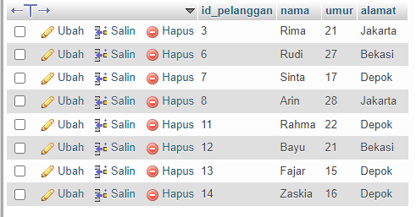

1. SELECT id_obat, SUM(total_harga) as total FROM `detail_transaksi` GROUP BY id_obat;

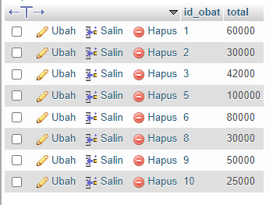

1. SELECT id_detail, SUM(total_harga) as total FROM `detail_transaksi` GROUP BY id_detail;

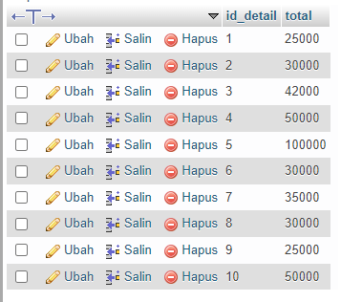

1. SELECT id_transaksi, SUM(total_harga) as total FROM `detail_transaksi` WHERE total_harga >=50000 GROUP BY id_transaksi ORDER BY id_transaksi ASC;

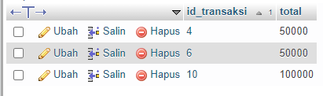

1. SELECT id_transaksi, SUM(total_harga) as total FROM `detail_transaksi` WHERE total_harga >=50000 GROUP BY id_transaksi ORDER BY id_transaksi DESC;

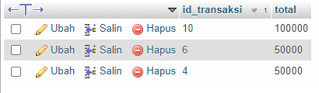

1. SELECT tanggal, jenis_transaksi as transaksi FROM `transaksi` GROUP BY tanggal ORDER BY tanggal ASC;

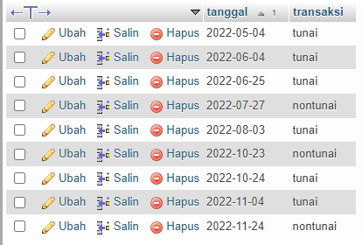

1. SELECT tanggal, jenis_transaksi as transaksi FROM `transaksi` GROUP BY tanggal ORDER BY tanggal ASC;

